**Stabilization Policy**

* Stabilization (monetary or fiscal) policy should be used if there is a large, protracted output gap caused by low aggregate demand.

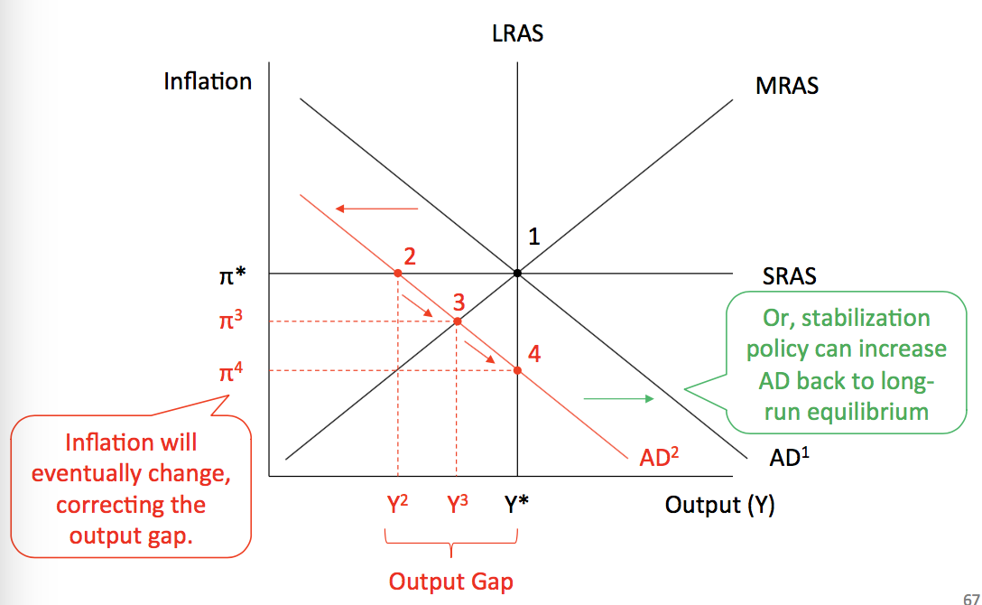

* If the output gap is caused by a fall in aggregate supply then there will be trade-off between output and inflation.

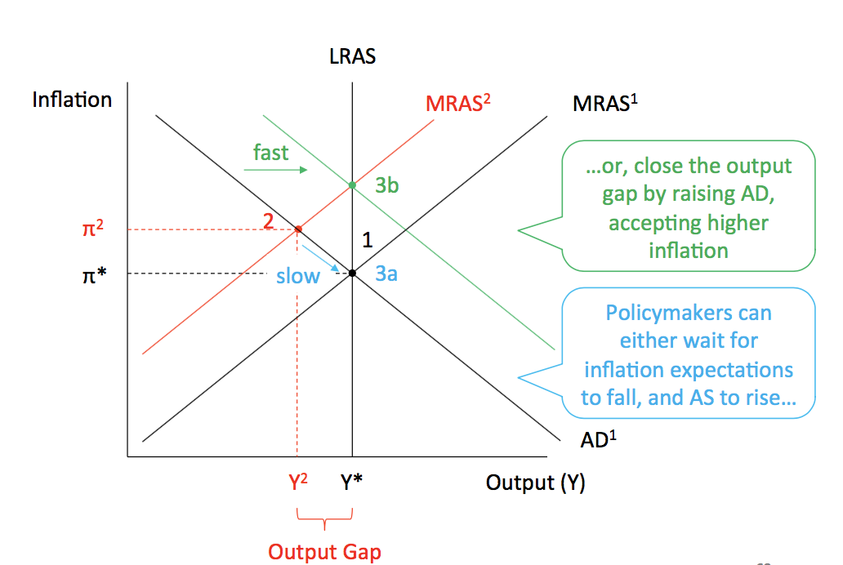

* Better understanding of stabilization policy can reduce GDP volatility. Structural changes in the economy can also reduce volatility:
* Changes in technology
* Business practices
* Better management of inventories
* Deregulation
* Shift towards services and away from manufacturing
* Increases openness to trade
* Freer international capital flows

**Central Bank Credibility**

* Central Bank Credibility is very important because it anchors inflation expectations, preventing the MRAS and AD curves shifting up:

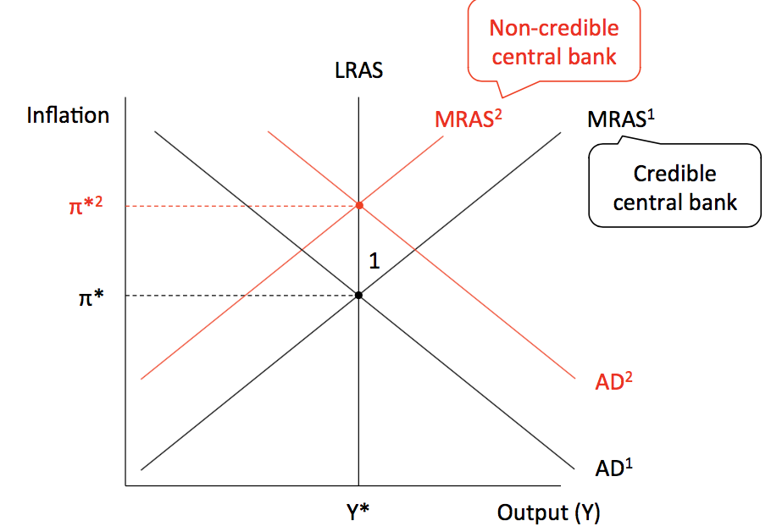

* This can be seen mathematically in the Taylor Rule and the Phillips Curve:

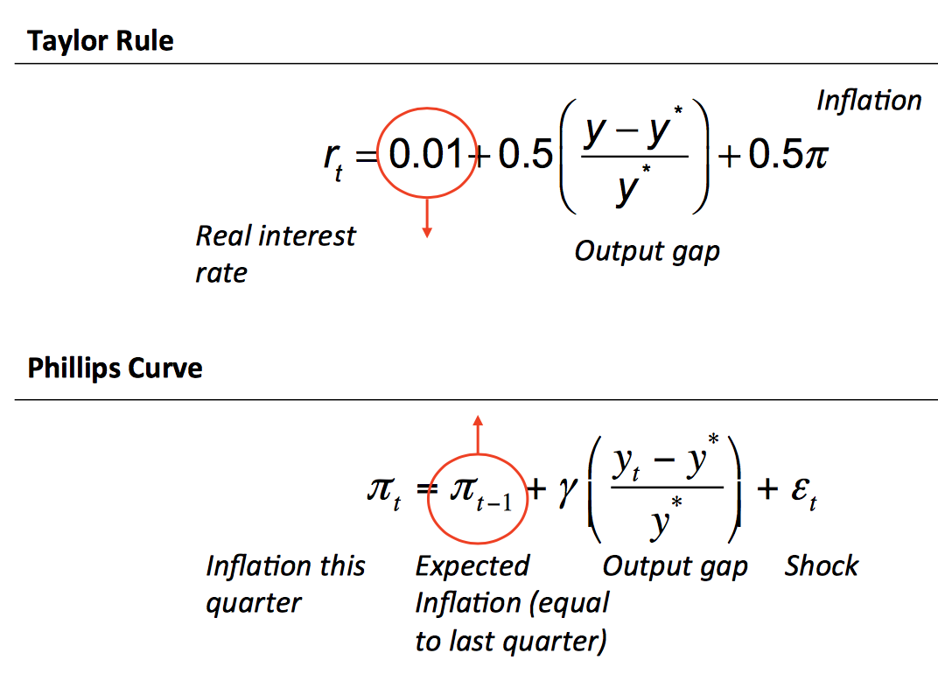

* Credibility can be improved by an independent central bank, with an explicit pi target and a reputation of fighting inflation
* Central Bank Independence:

1. Won’t lower rates for a short-term “Sugar hit” of GDP, eg. During elections
2. RBA very independent: own budget, long-term appointments, statutory independence

* Explicit inflation targets:

1. Reduces uncertainty in financial markets
2. Targets >0 because deflation is costly, and small +ve inflation allows real wages to fall if needed
3. Used around the world, including emerging markets like Brazil, Chile, Mexico and Peru

* Established reputation:

1. Targets must consistently been met
2. Better to be more aggressive on inflation to anchor expectations, which improves the trade-off between output and inflation

* The role for stabilisation:
* Recall the self-correcting mechanism: In the short run there might be output gaps, however in the long run the economy will go back to potential level of output because changes in inflation change expected inflation and this shift the AS.

1. If there is a contractionary gap, prices will start falling resulting in falling inflation and falling expected inflation – changes in expected inflation will shift down the AS. In addition, central bank will react to falling inflation by dropping interest rates, which will increase PAE, causing a movement along the AD.
2. If there is an expansionary gap, inflation will rise, rising expected inflation and shifting up the AS. The central bank will also react by increasing interest rates and we’ll move along the AD.

* However, the speed with which the self-correction mechanism takes place can be very slow due to long-term contracts and imperfections in the product and labour markets. (ie. Wages and prices might take a long time to adjust)
* In this case, there is still role for macroeconomic policy – stabilisation policy should be used if there are large and prolonged output gaps.
* If the economy experience a negative demand shock, then use either expansionary fiscal policy or expansionary monetary policy:

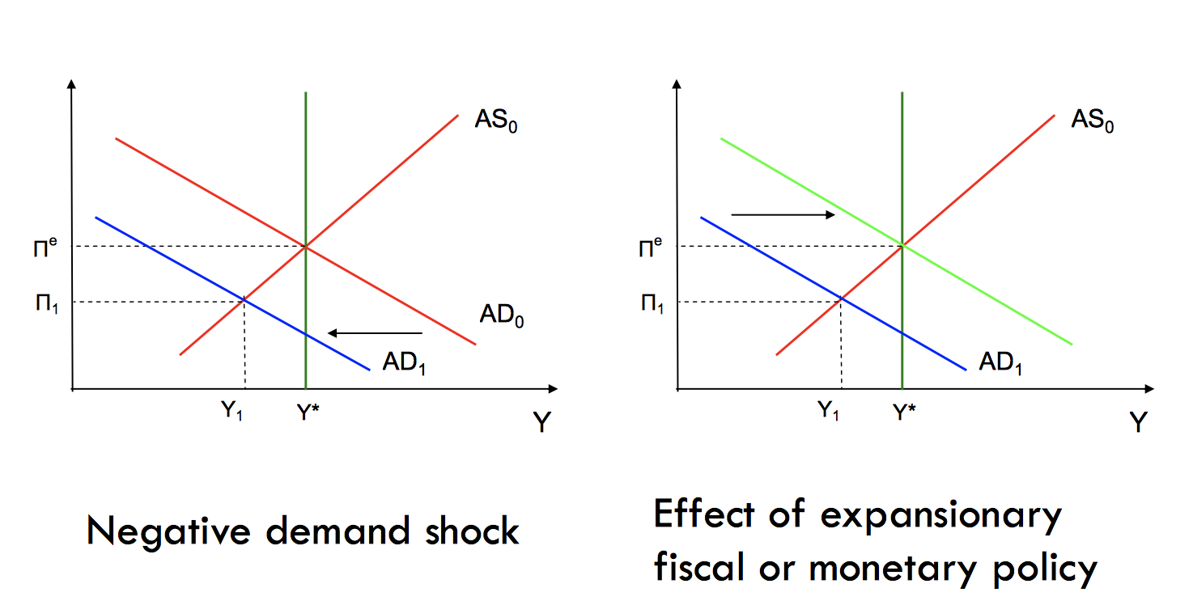

* If the economy experience a negative supply shock, then use contractionary policy.
* Policy Dilemma: if use expansionary fiscal or monetary policy, it will work towards closing the output gap but inflation will be even higher
* Thus, using accommodating policy -- a policy that allows the effects of a shock to remain.
* Implications:

1. In the short run, the economy experiences a period of contraction and higher inflation caused by the inflation shock, followed by an increase in output with inflation rising even higher.
2. In the long run, the economy returns to potential output, where it began, but now has a higher inflation rate. A possibly shorter and shallower recession is paid for with a higher long-run inflation.

* Anchored inflationary expectations: people’s expectation of future inflation do not change even if inflation rises temporarily:
* Inflation anchoring dampens response to an aggregate inflation shock
* Businesses and consumers believe the Reserve Bank will re-establish its target inflation rate
* This shortens the time required to close the recessionary gap from the shock, encouraging the Reserve Bank to maintain its original inflation target
* Inflation target:
* Inflation target shouldn’t be zero as:

1. Imperfect control over inflation means periods of deflation are possible
2. The Reserve Bank may use negative real interest rates at times, which can only be achieved if nominal rates are less than inflation, so nominal rates would be negative
3. Measured inflation overstates actual inflation, ie. A trul inflation of zero means measured inflation of about 1%
4. A small amount of inflation makes labour markets work better

* Fiscal policy and the Supply Side:
* Certain fiscal policies might affect the economy’s productive capacity, or potential output, as well as aggregate demand. For example:

1. Public spending on infrastructure, education, etc – shifts AD outward but also increases potential output in long-run
2. Taxes and transfer payments – more generous unemployment schemes associated to higher structural unemployment

* Summary:
* Stabilisation policy should only be used for a large and persistent output gap
* Anchored inflationary expectations occur when people’s expectations of future inflation do not change even if inflation rises temporarily
* An independent Reserve Bank is associated with a low inflation rate
* Fiscal policy is considered as supple side because it affects potential output
* Monetary policy has a shorter inside lag but a longer outside lag